2003 TEE
PART I (80 Marks)

Mark your answers to Questions 1–40 on the SEPARATE MULTIPLE CHOICE ANSWER SHEET, using a 2B, B or HB pencil. If you make an error, follow the instructions given to you on the answer sheet.

SELECT THE SINGLE CORRECT ALTERNATIVE IN EACH OF THE FOLLOWING QUESTIONS

      - Antidiuretic hormone (ADH) is

- synthesised and secreted by the posterior pituitary in response to a hypothalamic releasing factor.
- released from the anterior pituitary in response to a hypothalamic releasing factor.
- synthesised in the hypothalamus but secreted by the posterior pituitary.
- synthesised and secreted by the adrenal cortex.

- The diagram below shows the appearance of the bones in a number of vertebrate limbs. A comparison of these limbs is used to support the theory of evolution because such comparisons demonstrate

- inheritance of acquired characteristics.
- that variations from a common structure relate to a different way of life.
- that similar structures will arise from different ancestors.
- a fossil record that shows all vertebrates come from similar environments.

3. The human skin

- acts as a specific defence mechanism.
- carries helpful bacteria that aid in defending against other pathogenic bacteria.
- specifically excludes antigens once an individual is immunised against them.
- is made waterproof by secretions from the sweat glands.
4. This question refers to the list of features below.

- an S-shaped curvature of the spine
- both transverse and longitudinal arches in the foot
- a prehensile foot
- brain size of 400-500 cubic centimetres
- a centrally-placed foramen magnum

Which of the above features are characteristic of present-day hominids but NOT pongids?

- i, iii and iv only
- ii, iv and v only
- i and v only
- i, ii and v only

5. The next question refers to the list of features below.

- Brain size of approximately 1000 cubic centimetres.
- A dental arch with parallel sides.
- Use of the hand axe.
- Fossils found in Asia.
- Bipedalism.

Which of the above features are characteristic of Homo erectus but NOT Homo habilis?

- i, iv and v
- ii, iii and iv
- i, iii and iv
- ii, iii and v

6. This question refers to the list of responses below.

i. Sweating
ii. Increased breathing rate
iii. Shivering
iv. Increased depth of breathing
v. Vasodilation
vi. Vasoconstriction

Which of the following will occur when the human body is in danger of cooling?

- i, ii, iii
- ii, iii, iv
- iii, vi
- iii, iv, v and vi
7. To correct a drop in body temperature the human body may respond by increasing the metabolic rate of large organs such as the liver.

The direct stimulus for this response is

  - cold blood flowing through the pituitary.
  - cold blood flowing through the hypothalamus.
  - reduced blood flow through the hypothalamus.
  - reduced blood flow through the skin.

8. In what way may the problem of ozone depletion impact on the “greenhouse effect”?

- The increased amount of ultraviolet radiation due to ozone depletion may cause a major loss of ocean plant life.
- The gases that cause ozone depletion are the major cause of the “greenhouse effect”.
- The ozone hole over Antarctica will increase the rate of melting of the icecap and raise ocean levels.
(d) Low levels of ozone will lead to less absorption of reflected heat from the earth’s surface.

9. Which statement about lymph nodes is correct?

- They have a role in the pumping of lymphatic fluid.
- They contain cells that phagocytose bacteria.
- They produce antigens, vital chemicals that combat infection.
- They contain B-lymphocytes that engulf foreign particles.

10. Various surgical treatments for breast cancer require the removal of some or all of the lymph nodes in the armpit. The result of this is

- the ability of the body to fight infection is improved.
- the prevention of the spread of an infectious disease around the body.
- a reduced volume of tissue fluid.
- possible swelling of the arm from which the nodes were removed.

11. Voluntary muscle movement is controlled by

- an upper motor neuron in the brainstem and a lower motor neuron in the spinal cord.
- an upper motor neuron in the cerebrum and a lower motor neuron in the dorsal root ganglion.
- an upper motor neuron in the cerebrum and a lower motor neuron in the spinal cord.
- an upper motor neuron in the spinal cord and a lower motor neuron in skeletal muscle.

12. Which of the following is an example of an effector in a reflex arc?

- Pain receptor in the foot
- Motor nerve fibres in the spinal cord
- Motor end plate
- Skeletal muscle

13. If the ventral root of a spinal cord is cut, what will be the result in the tissue or region that the nerve supplies?

- Complete loss of sensation
- Complete loss of voluntary movement
- Loss of neither sensation nor movement but only of autonomic control
- A complete loss of both sensation and movement

14. An obstruction in the glomerulus would block the flow of blood into the

- renal artery.
- efferent arteriole.
- Bowman’s capsule.
- afferent arteriole.

15. Current evidence suggests that Aboriginal settlement of Australia may have occurred

- through island hopping along the Indonesian archipelago.
- across a land bridge connecting northern Australia with New Zealand.
- when ancient Chinese traders visited the far north coast of Western Australia.
- when islanders from the South Pacific drifted westwards to New Guinea.

16. Which of the following is an accurate statement concerning the modern agricultural lifestyle?

(a) Food supply remains at subsistence level only.
(b) The natural environment experiences pressure.
(c) It requires less energy than a hunter-gatherer lifestyle.
(d) It limits population growth.

17. Injury to the hypothalamus may result in all of the following EXCEPT

- loss of awareness of body position.
- a loss of temperature control.
- a production of excessive quantities of urine.
- a disrupted menstrual cycle.

Questions 18 and 19 refer to the diagram below.
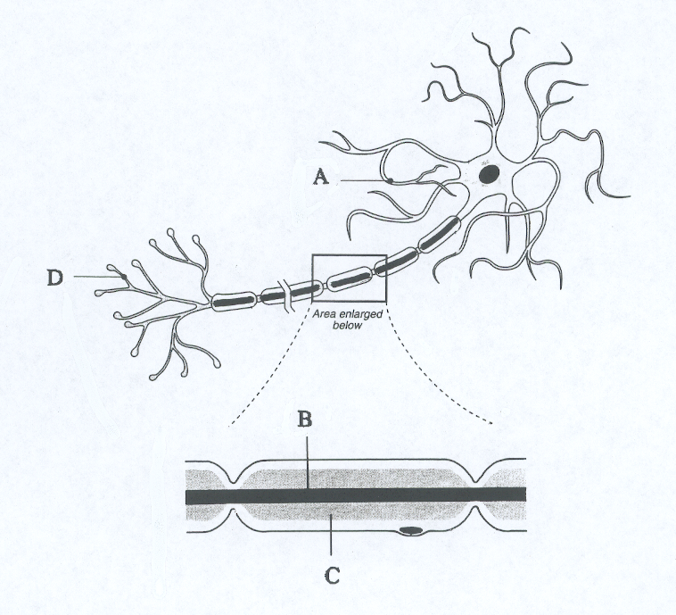
18. Which part of the structure shown above increases the speed of nerve impulse transmission?

- A
- B
- C
- D

19. Which one of the following statements about the neuron shown above is correct?

- This neuron does not show evidence of a Schwan cell.
- Structure B will produce the myelin sheath.
- Structure D receives impulses from other neurons.
(d) Structure A transmits impulses to the cell body.

20. Men are more likely to suffer from X-linked genetic conditions than women because

- males carry a Y chromosome.
- males possess only one X chromosome.
- most X-linked conditions are dominant.
- the Y chromosome carries little body information other than “maleness”.

21. Gonadotrophin-releasing hormone from the hypothalamus

- is released from the posterior pituitary gland in response to FSH and LH.
- directly stimulates the production of estrogen by ovarian follicles.
- is stimulated by progesterone in the luteal phase of the menstrual cycle.
- stimulates the release of LH and FSH from the anterior pituitary gland.

22. Which of the following is NOT an essential component in the formation of a new species?

- Variation among individuals in a population
- Reproductive isolation
- A high rate of mutation
- A change in the genetic composition of a population

23. A cline can be disrupted by

- a sudden environmental change in a particular locality.
- the removal of a large geographic barrier.
- the development of more tolerance regarding interracial marriages.
- the process of random genetic drift.

24. Individuals with blood group O

(a) have antigens A and B on their red blood cells.
(b) have antigen O on their red blood cells.
(c) always have at least one parent with blood type A or B.
(d) are denoted by the genotype ii.

25. Life on earth is thought to have begun approximately

- 63 million years ago.
- 500 million years ago.
- 3.5 billion years ago.
- 7 billion years ago.
Questions 26 and 27 refer to the table below.

Consider the table below showing data recorded for a person viewing a frightening horror movie.

Time (minutes) | 1 | 2 | 3 | 4
Cardiac Output  (L / minute) | 5 | 7 | 20 | 10

26. Concerning these data, which of the statements below is most correct?

- The sympathetic nervous system appears to be most active between 2 and 3 minutes.
- The parasympathetic nervous system is most active at 3 minutes.
- Adrenalin is secreted in response to increased cardiac output at 4 minutes.
- Between 2 and 3 minutes the hypothalamus adjusts the heart rate to meet a need for greater oxygen.

27. The changes noted in the person’s body are

(a) a result of the hormone thyroxine.
(b) a homeostatic response.
(c) designed to maximise oxygen delivery to the skeletal muscles.
(d) designed to ensure that carbon dioxide levels do not increase.

28. Which statement about the eye is CORRECT?

- The sclera separates the eyeball into anterior and posterior cavities.
- The lens is held in position by the ciliary body.
- Adjustment of muscles in the iris changes the shape of the lens.
- Light entering the eye is refracted by both the aqueous and vitreous humour.

29. In order to maintain focus on an object as it approaches more closely, the eye will

- contract the ciliary muscle causing the lens to bulge.
- relax the ciliary muscle causing the lens to bulge.
- tighten the suspensory ligaments on the lens and thereby flatten the lens.
- dilate the pupil so that more light can be used to accommodate the object.

30. This question refers to the diagrams (A and B) below, which show the population profiles of two countries.

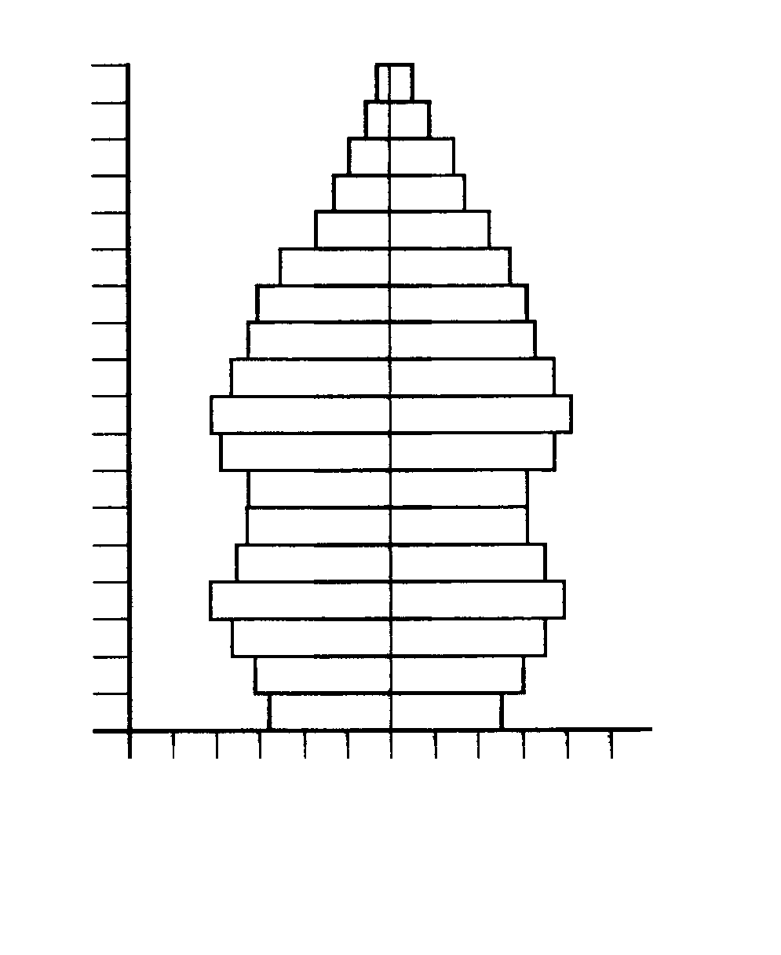
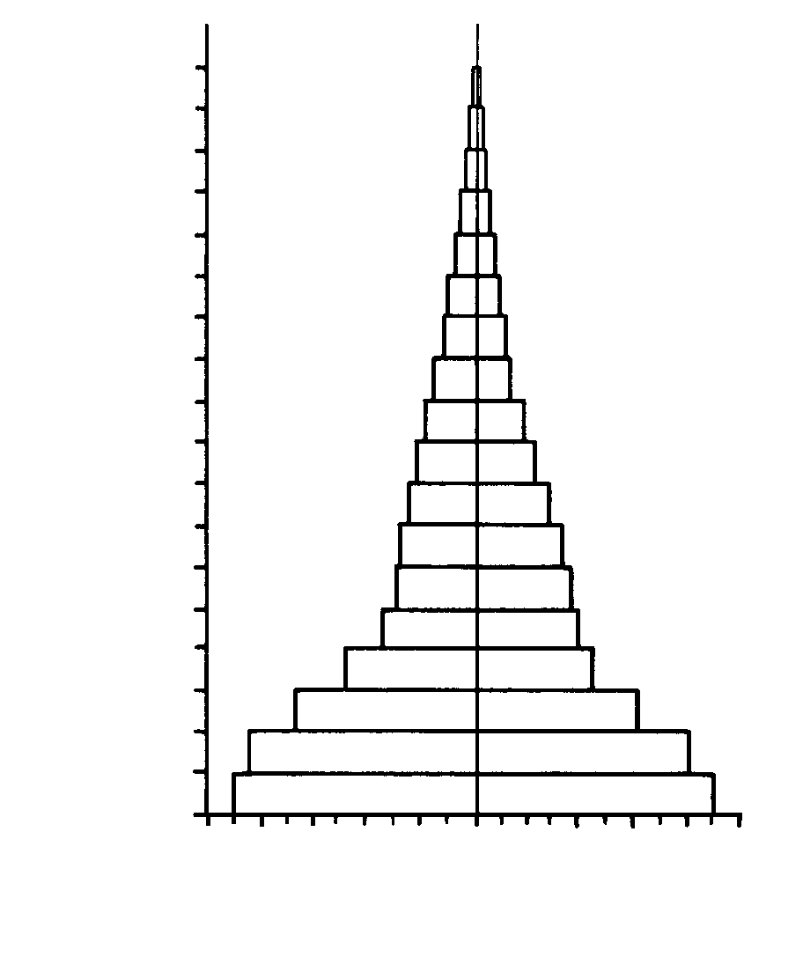
Males
Females
5
0
1
2
3
4
5
3
1
2
4
Percentage of population in each age group
Age group
0-4
5-9
10-14
15-19
20-24
25-29
30-34
45-49
35-39
40-44
60-64
55-59
50-54
80-84
75-79
70-74
65-69
85+
Males
Females
Age group
Percentage of population in each age group
10
9
8
7
6
5
4
3
2
1
0
1
2
3
4
7
6
5
9
8
10
0-4
5-9
10-14
15-19
20-24
25-29
30-34
45-49
35-39
40-44
60-64
55-59
50-54
80-84
75-79
70-74
65-69
85+

A B

If a country is to move from a population profile like that shown in diagram A to a population profile like that shown in diagram B, which of the following would be most useful?

- Increased pollution control
- Forced settlement of large populations into rural areas
- Large scale sanitation programs
- Legislation to promote early childhood education

31. The best biological argument against racism would be that

- racism creates social unrest.
- intermarriage between the major racial groups is becoming more frequent.
- the difference between the major racial groups is due to cultural differences only.
- there is as much genetic variation within a race as there is between races.

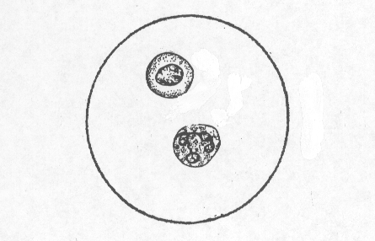
- Cells shown in the diagram below were observed using a microscope fitted with a 40X objective lens and a 10X ocular (eyepiece) lens. Given that the field of view for this microscope at a magnification of 100X is 200 micrometres, what is the approximate size of these cells?

- 10 micrometres
- 20 micrometres
- 30 micrometres
- 50 micrometres

33. If human cells were given essential nutrients and allowed to grow and reproduce in a closed test tube, what changes would you expect to measure in the test tube?

- An increase in temperature, as well as increased levels of oxygen and carbon dioxide.
- An increase in temperature, carbon dioxide levels and glucose but decreased oxygen levels.
- An increase in temperature and carbon dioxide levels but decreased levels of oxygen and glucose.
- A decrease in temperature as well as a decrease in levels of oxygen, carbon
dioxide and glucose.

34. The pituitary gland

- has no effect on the menstrual cycle.
- has a direct nervous connection to the medulla that helps control metabolism.
- is partly under the influence of nerves.
- will control the level of insulin in the blood during times of stress.

Questions 35 and 36 refer to the diagram below.

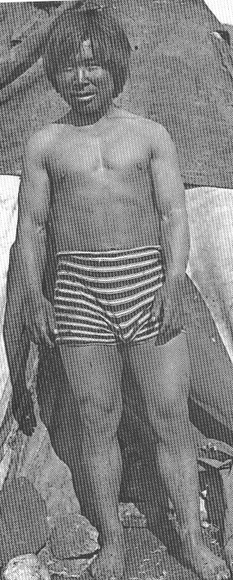

35. The Inuit of the Arctic regions are a population of people with the stereotypical body shape illustrated by the diagram above.

The correct term for this body shape and its importance is

- endomorphic: the low surface area to volume ratio will decrease heat loss.
- endomorphic: the high surface area to volume ratio will decrease heat loss.
- ectomorphic: the low surface area to volume ratio will decrease heat loss.
- ectomorphic: the short stocky body shape is most suited to the environment.

36. The stereotypical body shape of the Inuit has come about because

- the original settlers adapted gradually to the cold environment.
- only individuals with this body shape were capable of breeding.
- cold temperatures exert a selective pressure.
- due to genetic drift individuals with unsuitable body shapes emigrated.

37. Identify the CORRECT statement about evolution.

- Evolution can occur in a population without causing any change in gene frequencies.
- The development of resistance to antibiotics by bacteria is an example of evolution.
- The development of new features occurs when a species settles into new, uninhabited territory.
- Random genetic drift occurs more readily in large populations.

38. Choose the option that correctly matches the drug with its characteristics.

 | Drug | Depressant/  Stimulant | Tolerance and  Dependence | Hallucinogen
(a) | marijuana | depressant | tolerance and dependence may develop | possible
(b) | heroin | stimulant | tolerance but no dependence will develop | possible
(c) | alcohol | depressant | no tolerance but dependence may develop | not likely
(d) | nicotine | depressant | tolerance and dependence may develop | not possible

39. Which of the following will result in an increased breathing rate?

- Decreased oxygen levels detected by the hypothalamus will lead to parasympathetic stimulation of the diaphragm.
- Increased carbon dioxide levels detected by the medulla will lead to stimulation of the diaphragm by motor neurons.
- Increased carbon dioxide levels detected by the medulla will lead to sympathetic stimulation of the diaphragm.
- A need to lower carbon dioxide levels will be detected by chemoreceptors near the heart and will lead to direct stimulation of the diaphragm by motor neurons.

- This question refers to the diagram of skulls below.

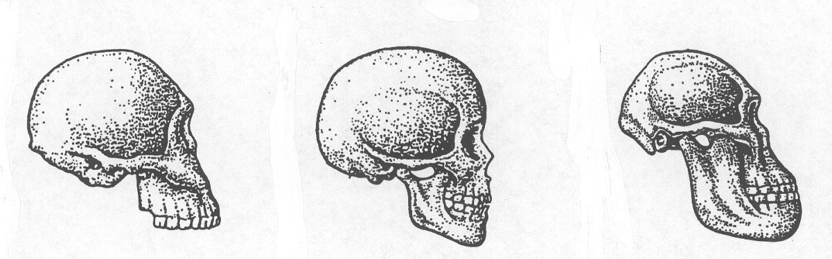
Skull A Skull B Skull C

(Note: These diagrams are not drawn to scale.)

Which dates most correctly match the fossilised skulls shown above?

 | Dates of skulls given as Years Before Present
 | Skull A | Skull B | Skull C
(a) | 1.7–2 million | 25,000–10,000 | 2–3 million
(b) | 30,000 | 15,000–10,000 | 2–3 million
(c) | 3–4 million | 125,000–50,000 | 500,000
(d) | 2.7–3 million | 400,000–50,000 | 1 million

PART II (80 Marks)

Write answers to ALL questions on the ruled lines after each question or in the spaces provided within each table. Write your answers in blue or black ballpoint or ink pen.

Question 41 (total 10 marks)

This question concerns the regulation of blood glucose.

- Name the endocrine portion of the pancreas and the cell type that produces insulin.

(2 marks)

- Individuals with type I diabetes are unable to produce sufficient insulin. If a diabetic patient collapses due to lack of insulin in their blood, what has happened to their blood glucose levels?

(1 mark)

- If insulin is given to the collapsed diabetic patient describe TWO intra-cellular processes that will occur in the liver.

(2 marks)

- Lack of insulin due to type I diabetes has been likened to starvation, even though the diabetic individual may have adequate food intake. Explain why the effects of a lack of insulin can be considered similar to the effects of starvation.

(2 marks)

- A healthy, young person with normal blood sugar levels was told to prepare for a surgical operation by not eating any food for 24 hours. If the blood sugar level for this person is measured after this 24 hour period, what is the likely result? Explain your answer.

(3 marks)
Question 42 (total 13 marks)

In 1968 a new variety of influenza appeared in Hong Kong. Named the “Hong Kong Flu”, it began to spread around the world quickly. In many laboratories around the world potential vaccines were investigated and trials performed to assess their effectiveness. The data recorded from one such trial are shown below.

Examine these data and answer the questions that follow:

Second Exposure
to Antigen
Initial Exposure
to Antigen

Vaccine by Injection

100 Oral (mouth) Vaccine

Antibody

Level

10

0 7 14 21 28 35 42 49

Time (days)

- For this experiment, identify the:

Experimental variable:

Dependent variable:
(2 marks)

- Compare the primary responses shown by the two groups of subjects in the experiment.

(2 marks)

- Identify four factors that would need to be controlled in the selection of subjects for this experiment.

(2 marks)

- Identify one method by which the vaccines used in the experiment could have been prepared.

(1 mark)

(e) Explain clearly, why the secondary response is quicker and larger than the primary response.

(3 marks)

(f) Given that an antibody level of 10 is effective at combating the disease, which vaccine would be more successful at controlling the spread of this flu? Explain your answer.

(2 marks)

(g) Apart from antibody levels, what other blood measurement could be taken to assess the effectiveness of the secondary responses?

(1 mark)
Question 43 (total 11 marks)

The pedigree drawn below represents the inheritance of a rare genetic condition that affects normal liver functions. Individuals who inherit this condition experience no symptoms until they become middle-aged (40–55 years). At this point in their life, affected individuals will present with severe digestive and blood composition problems.

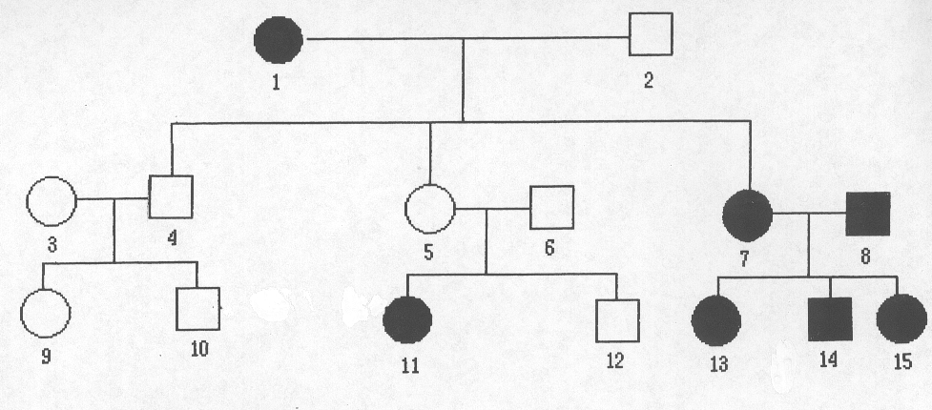
- What is the mode of inheritance for this condition?

(2 marks)

- Outline the evidence in the pedigree that provides definite support for your answer in part (a) above.

(3 marks)

- What is the chance that another child of individuals 5 and 6 will be affected? Show some working.

(2 marks)

(d) Despite a clear understanding of how this condition is inherited, it continues to appear in populations and families. Give a reason for its continued appearance.

(1 mark)

A family with a history of haemophilia (X-linked recessive) has the following pedigree:

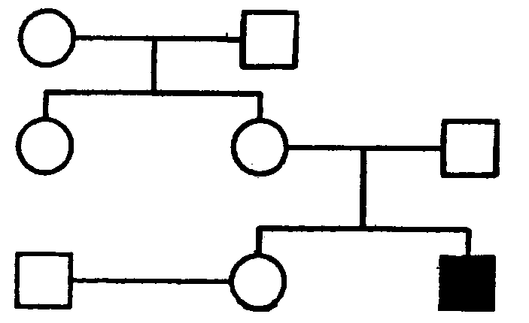
Jane

(e) What is the chance that Jane is a carrier?

(1 mark)

(f) What is the chance that Jane will have an affected daughter?

(1 mark)

(g) What is the chance that Jane will have an affected child?

(1 mark)

Question 44 (total 10 marks)

The data presented below were collected as part of an investigation into the relationship between thyroxine, thyroid stimulating hormone (TSH) and metabolic rate in humans. A normal, healthy human was given injections of thyroxine (one injection / day) on each of the first four days of the investigation and then levels of TSH and metabolic rate were measured.

Metabolic
Rate
(mL Oxygen
per minute)

 | 2 | 4 | 6 | 8 | 10 | 12 | 14

Time (days)
(Note: Thyroxine injections given on days 1 – 4)

Thyroid
Stimulating
Hormone
Levels

 | 2 | 4 | 6 | 8 | 10 | 12 | 14

Time (days)
(Note: Thyroxine injections given on days 1 – 4)

- Describe the pattern recorded for metabolic rate between day 5 and day 8.

(1 mark)

- Give a reason for the change in metabolic rate observed in the subject between day 5 and day 8.

(1 mark)

- Describe the chain of events in the body that most likely accounts for the levels of thyroid stimulating hormone between day 4 and day 7.

(4 marks)

- Describe and account for the speed at which metabolic rate changes after the injections of thyroxine.

(2 marks)

- In terms of temperature and breathing rate, what changes in the body of this subject are likely to have occurred between day 5 and day 8?

Temperature:

Breathing Rate:
(2 marks)

Question 45 (total 7 marks)

Examine the diagram below that represents some cells surrounded by tissue fluid and a capillary bed.

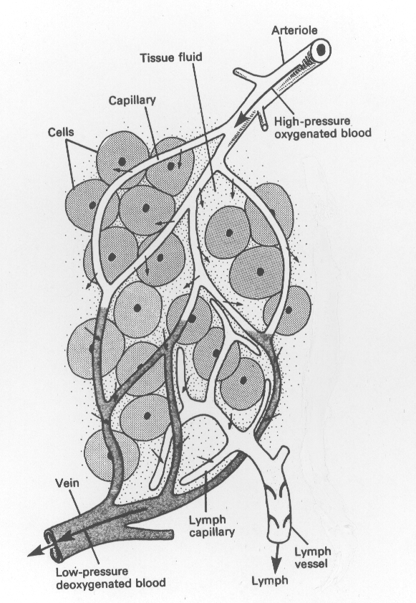

- Name two forces that are used to move water from the blood plasma into the tissue fluid surrounding the cells.

(2 marks)

- A person who becomes dehydrated will experience an increase in the concentration of plasma fluid. In what way will this affect the movement of water shown in the diagram. Explain why.

(2 marks)
- Describe the way in which the thirst reflex operates to reduce this effect.

(3 marks)

Question 46 (total 9 marks)

- What is meant by the term MUTATION?

(1 mark)

- Why are mutations an essential component of natural selection?

(1 mark)

- Apart from mutations name two other factors that are necessary before natural selection can take place.

(2 marks)

Carefully read the information in the box below.

In Nepal, the many Himalayan valleys have been an inhabited region for thousands of years. The valleys are steep sided and many isolated villages can be found at their peaks. These villages consist of 200–300 people. Despite the fact that they live in identical climatic and environmental conditions, there is a great deal of variation between the villages in the gene frequency of blood groups.

Scientists have rejected the idea that natural selection has accounted for these differences and believe genetic drift to be the more likely reason.

- From the information provided, identify three reasons why scientists may believe that genetic drift has caused the difference in gene frequencies.

(3 marks)
- In the table below, explain how the FOSSIL RECORD and DNA ANALYSIS can be used to support the concept of evolution.

SUPPORT FOR EVOLUTION?
FOSSIL RECORD
DNA ANALYSIS
(2 marks)

Question 47 (total 9 marks)

Examine the population data shown below.

Birth and Death Rates for Australia and Africa ( 1920 – 1993 )

Birth Rate
50
Birth
&
Death
Rates ( /1000)

Death Rate
40

30
Africa
20

10
Australia

1920 | 1930 | 1940 | 1950 | 1960 | 1970 | 1980 | 1990 | 2000
Year

(a) Ignoring the effects of migration, in the year 1980, was the population of Africa increasing or decreasing? Explain how you know.

(2 marks)

(b) Suggest two reasons why Africa may be slow to achieve a low birth rate.

(2 marks)

(c) Give an explanation for the pattern shown for Australia between 1950 and 1980.

(2 marks)

(d) What information is provided by the fertility rate of a population?

(1 mark)
(e) Increasing global population has led to an increasing demand for food. Apart from increased land clearing and improved mechanisation list TWO developments in modern twentieth century agriculture that have enabled global food production to match growing global demand for food.

(2 marks)

Question 48 (total 11 marks)

(a) Compare and contrast a chimpanzee skull with those of an Australopithecine and a modern human, by completing the table below. Use words when describing the dental arcade.

 | Chimpanzee | Australopithecine | Human
Shape of Dental Arcade |  |  | parabolic
Cranial Capacity (cc) | 350 - 450

(4 marks)

The diagrams below show the feet of a chimpanzee and a modern human, as well as some fossilised foot bones believed to be from an Australopithecine.

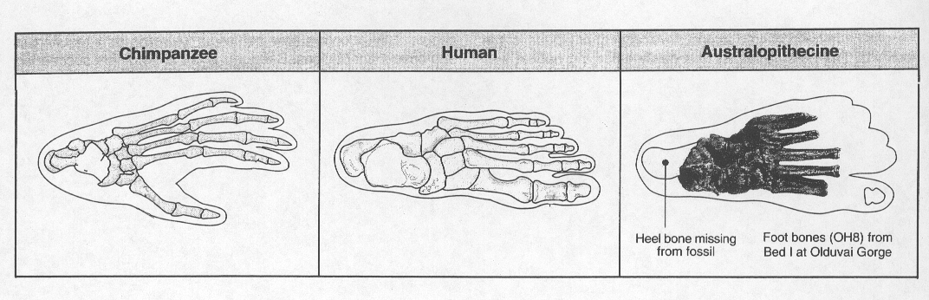
- Using the diagrams above, identify two features of the foot of the Australopithecine that would support the idea that Australopithecines were bipedal.

(2 marks)

Consider the diagrams below:
Note: The diagrams are not drawn to scale.

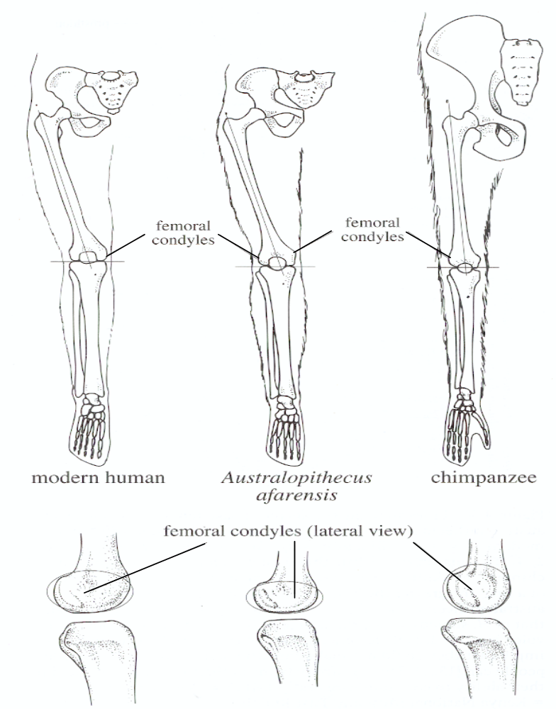
(This enlarged view of the femoral condyles is a side view of the knee)

- Identify two features of the femur shown in the diagrams above that would further support the idea that Australopithecines were bipedal.

(2 marks)

(Question 48 continued)

- Name ONE feature of the Australopithecine cranium that would assist bipedal locomotion.

(1 mark)

- Which hominid feature in Australopithecines appears to have evolved first, bipedalism or a large brain?

(1 mark)

- Use the information in the tables and diagrams to support your answer in part (e).

(1 mark)

PART III (40 Marks)

Answer ONE question from SECTION A and ONE question from SECTION B. Illustrate your answers with diagrams where appropriate. Up to TWO MARKS may be deducted for poorly structured answers: that is, answers in point form or diagrams not explained in the text of your answers. DO NOT WRITE ANSWERS IN PENCIL. Write your answers on the lined pages in your Question/Answer Booklet following the end of the questions.

SECTION A

ANSWER EITHER QUESTION 49 OR QUESTION 50 – NOT BOTH

QUESTION 49 (total 20 marks)

(a) In relation to the major constituents of plasma, describe how the composition of fluid changes as it passes out of the glomerulus and through the remainder of the nephron. Include in your answer reference to the specific parts of the nephron and how they bring about changes in filtrate composition.
(13 marks)

(b) Hospital patients who are in a coma experience a loss of function in many parts of their cerebrum and yet their heart continues to function normally.

Give an explanation for how the body is able to achieve this in the absence of a fully functioning cerebrum.
(7 marks)

OR

QUESTION 50 (total 20 marks)

(a) A major form of deafness is conductive deafness. Define this term and describe its causes.
(5 marks)

(b) Describe how normal balance, posture and locomotion are controlled by the human body.
(15 marks)

SECTION B

ANSWER EITHER QUESTION 51 OR QUESTION 52 – NOT BOTH

QUESTION 51 (total 20 marks)

Examine the diagrams below that show two fossilised Hominid skulls.

Skull A was found in southern Europe and its endocranial capacity was measured at 1600 cc. Skull B was found in southern Africa and its endocranial capacity was measured at 480 cc.

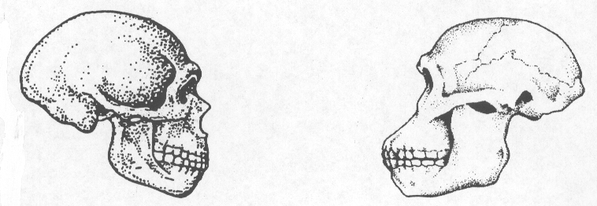
SKULL A
SKULL B

Note: These skulls are not drawn to scale.

(a) If you were asked to date SKULL A to an ABSOLUTE date, describe the appropriate type of data you would collect and describe the way in which you would interpret these data.
(6 marks)

(b) If you were asked to date SKULL B to a RELATIVE date, describe the appropriate type of data you would collect and describe the way in which you would interpret these data.
(6 marks)

(c) Describe likely cultural artefacts that would be found in close association with each of these skulls.
(8 marks)

OR

QUESTION 52 (total 20 marks)

(a) The hominids lived a hunter-gatherer lifestyle for a long period of time that placed limitations on the ability of their society to develop greater complexity.

Briefly describe the hunter-gatherer lifestyle and discuss those aspects of it that limit development of the society.
(8 marks)

(b) Describe the features and requirements of the industrial lifestyle.

Using specific examples, describe the impact of this lifestyle on the quality of air and water in the natural environment.
(12 marks)

END OF PAPER
Check that you have written your Student Number on the front cover of this booklet.

ACKNOWLEDGEMENTS

Question 2: Figure from: Allan, R., & Greenwood, T. (1999). Year 12 Biology (1999) student resource and activity manual. Queensland: Tutor Courseware, p. 342.

Question 20: Figure from: Allan, R., & Greenwood, T. (1999). Year 12 Biology (1999) student resource and activity manual. Queensland: Tutor Courseware, p. 50.

Question 30: Figure from: Newton, T.J., & Joyce, A.P. (1995). Human perspectives: Book two. Sydney: McGraw-Hill, Figs. 17.2, 17.3, p. 206.

Question 32: Figure modified from: Beckett, B.S. (1988). Illustrated human and social biology. Oxford, UK: Oxford University Press, Fig. 2, p.59.

Question 35: Figure from: Park, M. A. (1996). Biological anthropology. Mountain View, CA: Mayfield, Fig 13.6, p. 276.

Question 45: Figure from: Klein, R. G. (1999). The human career: Human biological and cultural origins (2nd ed.). Chicago: University of Chicago Press, Fig 4.31, p.208.

Question 45b: Figure from Allan, R., & Greenwood, T. (1999). Year 12 Biology (1999) student resource and activity manual. Queensland: Tutor Courseware, p. 376.

Question 46: Figure from: Beckett, B.S. (1988). Illustrated human and social biology. Oxford, UK: Oxford University Press. Fig. 1, p.68.

Published by the Curriculum Council of Western Australia
27 Walters Drive
OSBORNE PARK WA 6017

